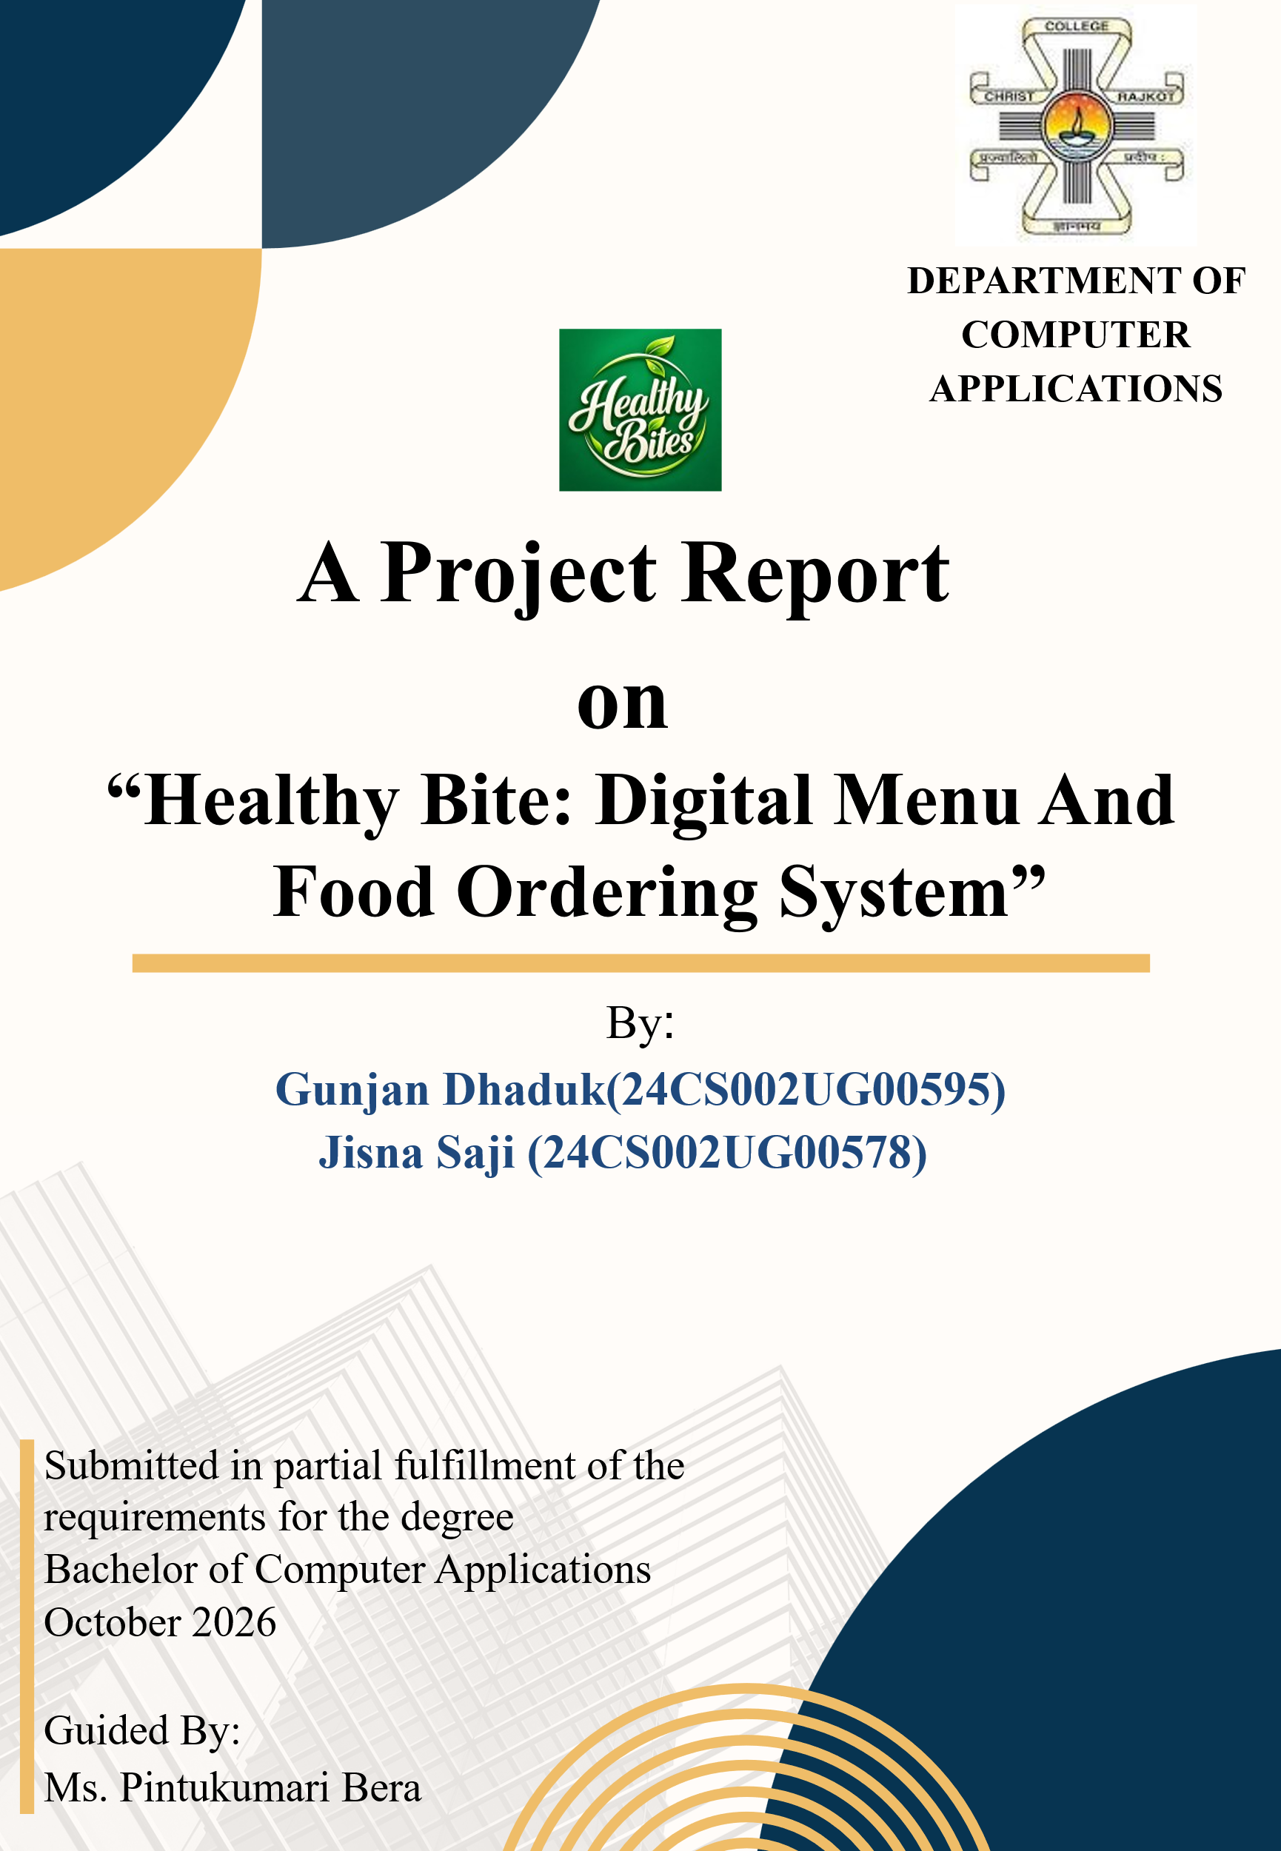
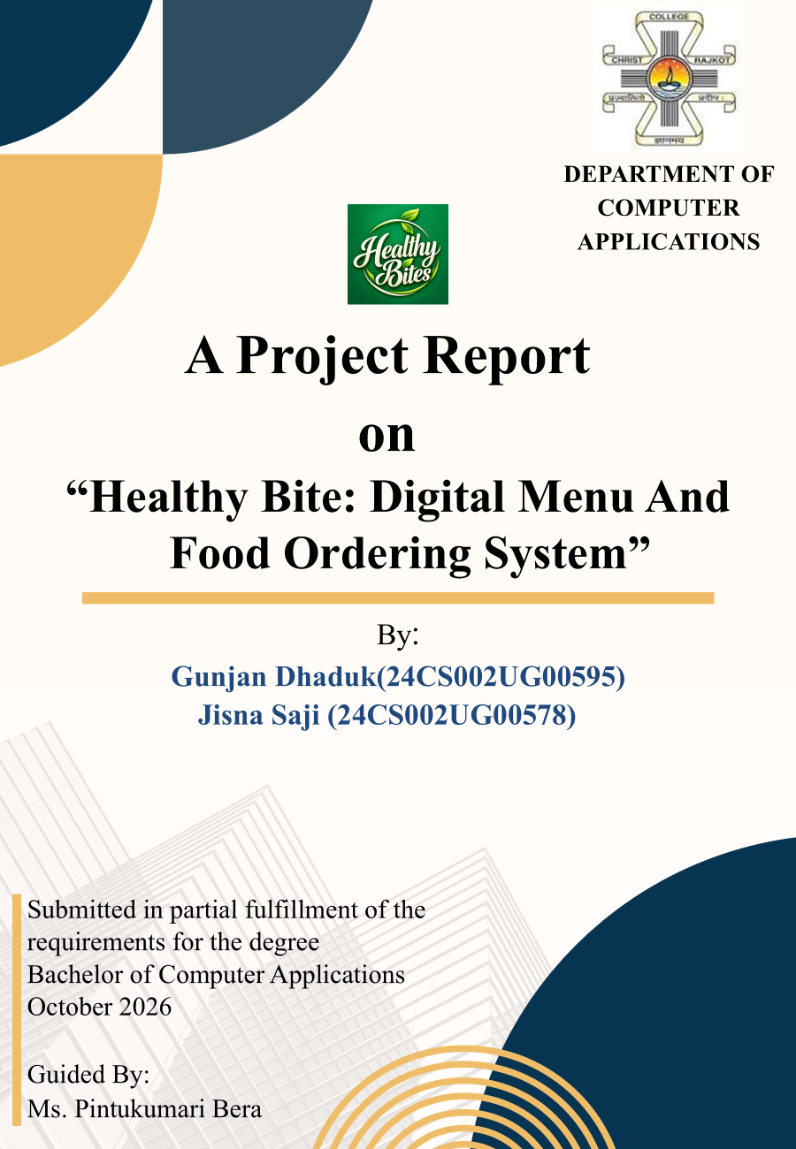

Certificate
This is to certify that the work presented in the BCA project report entitled “Healthy Bite: Digital Menu And Food Ordering System”, submitted to the Department of Computer Applications, Christ College, Rajkot, in partial fulfilment of the requirements for the award of the Bachelor of Computer Applications, is an authentic record of the work carried out by Gunjan Dhaduk & Jisna Saji during the period from June 2026 to October 2026 under the supervision of Ms. Pintukumari Bera

We also certify that this work has not been submitted, either in part or full, for the award of any other degree elsewhere.
Signature of Gunjan Dhaduk : __________
Signature of Jisna Saji : __________
This is to certify that the above statement made by the candidate(s) is/are correct to the best of my knowledge.
Head | Guide
Dr. Shailendrasinh Jadeja | Ms. Pintukumari Bera
Department of Computer Applications | Department of Computer Applications
Christ College, Rajkot | Christ College, Rajkot
Place: Rajkot
Date: __________
Acknowledgement
When we embarked on this project, it initially appeared to us as an onerous task. However, as we progressed, we realized that we were not alone in this journey. We wish to express our sincere gratitude to Rev. Fr. (Dr.) Jomon Thommana, Director, Christ Campus, and Dr. Yvonne Fernandes, Principal, Christ College, for their constant support and encouragement.
We are deeply thankful to Ms. Pintukumari Bera, our project guide, for their invaluable guidance, suggestions, and the freedom they provided us throughout this project. Without their mentorship, the completion of this project would not have been possible.
We extend our heartfelt thanks to Ms. Pintukumari Bera, our friends for offering their unwavering support, encouragement, and assistance during the preparation of this project.
Our gratitude also goes to our group members, classmates, and well-wishers, whose generous help made this work considerably easier. Finally, our deepest thanks to our parents, who patiently bore with us through the challenges and supported us with a smile throughout our study period and beyond.

Gunjan Dhaduk
Jisna Saji
Christ College, Rajkot
October 2026
TABLE OF CONTENTS
Chapter / Section | Title & Major Subsections | Page No.
Chapter 01 | Introduction | 1
Chapter 02 | Objectives, Scope, Features, Actors | 2
Chapter 03 | System Analysis (Problem Definition, Existing vs Proposed, Feasibility) | 4
Chapter 04 | SDLC | 6
Chapter 05 | System Design & Modeling (DFD Levels 0/1/2, ER Schema, Activity, Use Case, Process Flow, Class) | 8
Chapter 06 | Data Dictionary (All 17 Relational Tables Specification & Constraints) | 21
Chapter 07 | System Implementation (Directory Map, UI Screenshots Walkthrough) | 36
Chapter 08 | Code Explanations | 47
Chapter 09 | Testing & Quality Assurance (Test Plan, Approach, Summary, 74 Test Cases, Final Statement) | 57
Chapter 10 | Result (Step-by-Step Test Execution & End-to-End Workflow Verification) | 64
Chapter 11 | Conclusion & Future Scope (Academic Summary, Scalability, Future Scope) | 65

